# Work notes about Gravitic Engine 7: (GE7)

## Intro to Work Notes:

The following document contains varying descriptions of a theoretical device to try to generate electricity from the rocky or liquid, surface or subsurface of a large mass (i.e. planet, moon), through the circulation of liquid in a cycling pump driven by counterweights involving pulleys with a strong degree of mechanical advantage. As of 2025/01/06, the hope of the following work notes is to better define manuals, procedures, and research sprints to develop the engine in a later hardware prototyping phase.

## BE Description

The main goal is to achieve a fully functional prototype, within the period of the program. With the additional of a CAD artist doubling as a PM, a ME doubling as a builder, and an EE doubling as a software engineer, a small team of people could achieve this. Then start working on making the pump as efficient as possible. To figure out payback time for the technology.

A secondary goal would be to patent the pump and any improvements found to its design. IP in electricity generation is highly competitive, and for good reason. The patents that are valuable are truly priceless.

A tertiary goal would be to have a bundle of IP ready to be licensed to larger renewable, construction or industrial concerns. Groups that want to produce power on-site or build power-plants for other businesses. This would involve some development software.

Technical Risks:

1) I am doing math on a spreadsheet, and drawing different versions on graph paper.

Spreadsheet math is the existing simulation of the device, but I could be off on a single variable. That could trigger a redesign of other parts of the device. There is a delicate mass ratio of components that allows the device to operate. Change one mass, then the others need to change to. For example, if a valve is one pound heavier than it should be, that could cause the prototype to fail to work initially, and involve some wasted time, replicating work.

To compensate, I have to find the Goldilocks area of a mass ratio, where all stages of the pump have good margins in case of an error. Designing the prototype to be flexible (make some spaces wider or taller than necessary, just in case a redesign requires a larger version of a component.)

2) The primary energy source is unknown. This means the device's scientific feasibility needs to be viewed with a healthy amount of skepticism. I am confident that the math suggests that an unknown energy input exists, and that the pump can function.

The main danger is convincing a team that this question (what is powering the pump?) is fairly academic. I don't think it will help speed up prototyping, only slow it down in some type of fruitless debate.

That said, there are three different theories for what primarily powers the pump:

a) the potential energy of the molecular bonds in the cable (not breaking over time)

b) the gravitational potential energy of the masses between the pump and the center of the Earth

c) a fourth dimensional energy source, related to the projection of gravity in the third dimension and the relative rate of the passage of time. This may be considered an entropic potential energy source.

3) Valve durability: This pump uses valves, and the valve turns per day is high. Finding a cost-effective, repairable valve that can last for tens of thousands of cycles has been difficult. This valve may have to be made in house.

## Definition of a Gravitic Engine:

Low-power pump that circulates liquid through a closed loop starting from a disk-like pump chamber through a narrow tube to accomplish one of three goals: pumping liquid to higher reservoir, generating power through kinetic energy directly, or using liquid as a method of heat exchange. It is driven by counterweights using the mechanical advantage of a pulley system.

Legal Definition of a Gravitic Engine

Simple version: An engine having a combination of liquid valves, plunger pumps, counterweights, and compound pulley systems, designed to serve as a low-energy pump of liquid coolant.

Alternate definition for power generation:::

““This invention relates to an engine for generating electricity and more

particularly, but not by way of limitation, to an engine having a combination of liquid

valves, plunger pumps, counterweights, and compound pulley systems. The engine is

under microprocessor control and called a “Gravitic Engine”.””

## Theory of Operation

The simple version: Counterweights drive a plunger pump up and down, shooting liquid out a narrow pipe. The fast moving liquid inside the pipe can be used to either cool another machine and/or to generate electricity by turning a generator. Prototyping can tell which function should be prioritized in future development.

A less short version is available below.

*******************************************************

*******************************************************

But it may be better to view the *folder* of pictures also contained in this storage device, alongside the PROC picture, for specific procedural steps of an earlier version of the device. There are several improvements discovered after these drawings were made, but it is a good start. Ideally, an up-to-date animation can be drawn to more quickly and easily bring the curious up to speed from later CAD projects.

A raised counterweight (CW) is filled with liquid, from a small raised tank above the CW, to drive the plunger of a roughly disk-shaped pump down below. The CW is filled with a small amount of liquid compared to the volume of the plunger pump’s chamber. The pulley system delivers an incredible mechanical advantage to drive the much heavier plunger. The CW had to be raised much higher, to exchange large force on the pump across a short distance for a small force across a long vertical distance. The pump chamber was allowed to fill through the opening of a floodgate, by a separate, but similar CW, from a large raised tank (reservoir) above itself. The larger tank acts as a reservoir and stores the optional turbine.

Once the first CW raises the plunger to its highest height, the pump is primed. The floodgate at bottom of the pump chamber closes. Another raised CW is then filled by the small raised tank. This CW is slightly larger, and will drive the pumping action of the chamber.

Liquid rapidly flows out of a narrow tube at the bottom of the pump chamber. *Either* to drive a turbine and return to reservoir, or to pass through a heat exchanger to cool some other machine. The first prototype test can provide enough data to make an informed decision on which (and possibly *when* each) research path should be taken.

*******************************************************

*******************************************************

## Thermodynamic Discussion

The single pump chamber is only driven by a handful of much smaller valves controlling the weight of liquid. This allows for a low-power pumping solution compared to traditional cooling systems. Motorized ball valves, sensors, wireless chargers, batteries, and microcontrollers are the main contributors to input electrical energy. The main energy outputs is the driven turbine and waste heat due to friction. It may be easier to view the total energy as two batteries with a certain potential energy. Let’s try to summarize some results in a set of equation(s):

Raised Tank: Uelectrical,in  = Upotential energy of raised liquid, out + Qdue to friction

Kinetic Energy: Uelectrical,in  = Ekinetic energy, narrow tube, out + Qdue to friction

Generator design: Uelectrical,in  = Uelectrical energy,generated,out + Qdue to friction

The first term on the right side of each equation above has been estimated. These terms are be higher (or ridiculously higher) than the total input energy per cycle of over a dozen small valve turns, sensors, wireless battery charging, signals, and microcontrollers. Factoring in pulley efficiencies, stretching, liquid-recirculation electrical costs, with roughly twenty feasibility logic checks.

Common sense says (and the first law of thermodynamics implies) the electrical energy out is less than the electrical energy in, due to the loss of energy from friction that creates waste heat. The energy in also includes the electrical loss of driving a lower “recovery” pump for some percentage of liquid to be driven back up to fill counterweights in a future cycle. Energy must be conserved in a closed system. If all liquid is repositioned correctly in a steady state cycle, then the potential energy on either side of the equation should cancel out. The gravitational waves due to objects accelerating should be considered infinitesimally small, so that can be rounded to zero.

I propose a fourth term in the original equation, and possibly a new dimension in the system boundary. Some type of energy that may explain the excess amount of calculated kinetic energy of the total circulating liquid passes through the narrow pipe and hits the turbine.

Uunknown + Uelectrical,in  = Uelectrical,out + Qdue to friction

There are a few theories about where the theoretical surplus electrical energy could be coming from. Some type of resource must be consumed. The following bullet points detail energy source speculation:

* 3D: Potential energy stored in the high-tension cables (or ropes) is released in molecular changes during wear and tear over the “lifetime” of the use of the cable or rope. This may also apply in a similar way to support structures within the device.
* 3D: Decrease in the potential energy of groups of masses underneath a Gravitic Engine, between the engine and the center of mass of the planet. Due to large stresses of a cycle, vibrations would be sent through the ground. Increased compression and rock shifting over time (concentrating of masses closer to each other) takes potential energy away into the larger system of the mass of the planet. It pokes the surface of an inflated balloon.
* 3D: Decrease in thermal energy. Device gets colder and/or the whole surrounding system as liquid spends much more time expanding than compressing. The way the circulating liquid expands into a larger area over a longer time could justify an endothermic process, decreasing the temperature.
* 4D: Graviton (A 4D structure that some physicists believe exists.)
* 4D: Change in the local rate of the passage of time
* 4D: Decrease in the entropic potential of the entirety of the masses involved. This could be related to a measurable (or estimable) 3D decrease in potential energy.

If every object (including masses) moves at the speed of light in the fourth dimension, and time slows down around masses to help conserve the speed of light in the fourth dimension, then there may be some thermodynamic arguments to require gravity to work harder or for in-system potential energy to be restored, in a steady state cycle, in this case.

I believe that any field has a special case where energy can be extracted from it. The current force balance equations in the spreadsheet and logic checks show the feasibility of the 3D device. But the 3D thermodynamics requires an additional unknown 3D term, to explain the output excess in electrical energy.

Effectively, there is a promising contradiction in 3D math, between the force balance equations working out OK, but the thermodynamic equations need for an additional term to satisfy an increased electrical output. Only prototyping can really confirm that the theoretical model presented in the spreadsheet (see storage device) is valid.

## New Improvements:

* ***Ellipsoidal pipe (not circular) to help speed up the fill time of the pump chamber
* Recent: CW#1 and CW@2 must be connected over the top, too.
* Use vertical, reinforcing structural cables between relatively narrow pipes to allow them to hang underneath each other, but avoid vibrating too much (I am not sure if this should be drawn in patent drawing, it would prevent the viewing of the more important components)
* Use floodgate trick on CW#1 and #2 fill, to further decrease electrical input (see CW#4).
* Counterweights should be plastic (or another lighter than metal material) to increase weight difference between pump stages. And to increase overall feasibility of the device. So CW#1 and similar should look like IBC cages (see movie sets). Plastic shells, metal cages for reinforcement. See “New CW#1” notes from 12/11/2024.
* Place Opaque Pipe around CW rail, to help reduce evaporation losses and add structural support. Could be primary structural support.
* Complementary tech: Wind turbines and solar panels can be placed above or within the top of the pump towers, via cables. This allows for some flexibility in tower bending, and storm resiliency, and uptime of the low-power circuits involved in operating valves, temp. regulation, sensors, or computing devices that high up. In the rarer pump-hydro combined designs, this can also help drive a more traditional centrifugal pump, regardless of uptime of pump chambers.
* First Pulley: Improvement: Use 3:1 mech advantage of two pulleys, 3 tension, before any redirect pulleys guide rope horizontally. Can this be done for both CW#1 and CW#2?
* Moderate MBVs: Replace single, moderate MBV below CW#1 and CW#2, with two smaller MBV’s to avoid a single point of failure, decrease cost, decrease power rating, allows pulley rope or cable to pass through the near center of the counterweight
* Experiment with IBC (plastic in metal cage) for pump chamber. Perhaps only cylinder of plunder needs to be metal, and disk can be mostly plastic to reduce overall weight of plunger.
* Optional: Share CW’s from same or different pump chamber in a single pipe, to reduce material cost
* Required: Verify presence of upper and lower breaking structures on plunger of proof of concept prototype
* Decrease number of generators. One generator for every few towers, (not one generator per tower, anymore, too expensive. Many pump chambers may be needed to justify the cost of a generator). This improvement is designed to increase the tower to generator ratio. Large generators powered by narrow pipes from the pump chambers are better stored closer to the ground, to be installed and replaced via forklift (instead of crane), minimizing weight or mass in the upper parts of the tower. However, generators should also be stored high enough above ground to minimize flood risk.
* Place compound pulleys directly above the plunger to minimize rope/cable length, so those pulley’s move horizontally taking advantage of horizontal space above (and usually in between) pump chambers.
* Place a drain valve on inlet pipe below each pump chamber and towards bottom of each pump chamber for maintenance.
* Rejected: Unicycle-like Big Pulley next to small pulley, next to plunger rods for floodgate, for more efficiency in CW#3 pulley setup. First compounding pulley is fixed bottom of plunger rod to reduce
* ***Rigging: Use a turnbuckle to tighten ropes and cables precisely.
* Overflow pipes need to exist to exchange air for liquid between upper reservoir tanks, and possibly between upper reservoir tanks and outside air.
* Coolant: On a coolant embodiment, narrow tubes needs to be able to drain properly for maintenance. Consider a downward spiral to maintain velocity. Alternate use: Velocity of liquid helps mix solution (like R19 or other higher density solution or existing solutions, like PGW).
* Feasibility: If counterweight-rail towers are high, add additional guiding pulleys to guide cable/rope to counter misalignment due to tower bending due to wind or the operation of the device. Revisit mass of plunger reduction to reduce height and number of pulley’s.
* Tower Structure: Pools underneath neighboring pump stacks share pipes between them, in case any recovery pump goes down.
* Recovery Pump: Fills from underneath, too. Correction from earlier drawings where it would fill on top.
* CW rails hexagonally surround a pump stack, allowing for cost savings in support structure
* In Kinetic energy embodiment, upper reservoir and lower reservoir may be combined to save on cost.
* In kinetic energy embodiment, enough recovery pumps are fully below the CW rails in vertical position, to pump or “recover” each other’s CW liquid.
* Ball bearings or similar device between bottom of plunger and side wall of pump chamber

## Use Cases:

Energy Storage: Use the Gravitic Engine as a pump, moving liquid from a lower reservoir to a higher reservoir, within the context of a pumped hydro storage facility. (Rhe Energize)

Power Generation: Use the Gravitic Engine as a pump, moving liquid at a high output velocity to drive a turbine to generate electricity.

Coolant: Use the Gravitic Engine as a pump, moving cool liquid in circulation to cool a building or a piece of infrastructure. Hybrid: Coolant still drives a small turbine that powers a refrigerant cycle. This would allow for self-cooling of the liquid without additional input electricity.

Underground: Use the Gravitic Engine as a pump, underground, for any of the above mentioned purposes. The device does not require atmospheric exposure, but would require sufficient volume to operate, but especially for an underground energy storage application.

Black-Start Solver: Use the Gravitic Engine as a low-power pump. To help a grid recover from a severe blackout situation. Only a small 10-50watt battery would need to survive or be powered to start up one pump. Then the pump creates enough energy to startup other pumps in the stack. Pump stack starts up other pump stacks, to achieve a powerplant recovery.

Dual-Use: Provide infrastructure to change where the narrow tube goes, seasonally, monthly, weekly, daily, intrahourly, so that the pump can be used as some combination of the above regularly.

Nuclear Liquid Metal Pump: Use the Gravitic Engine as a low-power pump, to move high-density liquid (liquid metal, like bismuth) through the jackets around a nuclear reactor, to help with the cooling process and radiation containment. (Zap Energy)

## Research Path and Business Plan

## Feasibility Stress Testing (2-4 months):

Hire Project Manager, hire CAD designer (ideally, same person)

Hire external accountant firm for payroll, purchases, if necessary

3D CAD Drafting and Simulation, (select software with reputation for modelling pulley and prestressed cable designs, look for best efficiency point or range)

Experiment with different simulated liquid solutions for different applications in the model: Clean Water, PGW, R## (or similar from Rhe Energise). Metal liquids (Mercury and GBLM) were already explored, but their reactivity, toxicity, and price/volume strongly rule out their use on the planet Earth.

Explore, in math and CAD, how reducing the mass of the plunger could assist in decreasing the cost of materials and number of pulleys in the device

Use Operations Research(OR) mathematical models of device, to find best mass ratios to increase productivity of device, by optimizing variables with simultaneous “yes/no” and “how much” decisions.

Compile and Keep a running list of potential patent claims

(CW#2 > CW#1, etc., Review old lists)

Math Improvement(s) (following simulation discoveries),

Checked: Revisited force loss due to stretch (closer to 75% from 98%)

Research site selection,

Create CAD project to read CSV of Spreadsheet => CAD auto-generation of model,

Before next phase, Hiring rest of full-time team: ME, EE, Full-time Accountant

## First Prototype, Proof Of Concept (6-10 months):

Pulley Verification (Choice: HMPE (Dyneema, ultra, UHMWPE ) vs. Wire Rope or both)

Practical Load Test on Partial Tower

Test Assumption: Dyneema(x?) in wet parts of machine, wire rope everywhere else?

Counterweight development (ME and EE)

Install single pump chamber and seal test

Pump chamber *pressure* test

Cycle test of pump chamber with reduced design, sensor feedback

Prior Art Search, Hire In-house Patent Lawyer, Grant/Application Filer, near end of testing

Non-dilutive grant application(s) begin, start applying for patents

Temperature sensors can register how different parts of device change in temperature through a cycle

Test design against human and in-house AI review processes

Test different “relatively narrow” pipe diameters, material lengths to see how that can influence

Cycle time

Flow rate, kinetic energy

Max height(maximum height that pump can push liquid up to)

This could be very useful for future pumped hydro projects.

Evaluate stress or shaking risks

CAD Drafting of fully-functional prototype

## Second Fully-Functional Prototype (6-10 months)

Commit to purpose: cooling, power generation, hybrid heat-pump, energy storage (pumped hydro), or blackstart solver

Build pump chambers on top of original (multi-pump stack)

Build (or raise) reservoir tank above that, (remember to shade such tanks)

Test startup and performance requirements for real-world applications

Test long-term durability and maintenance requirements

Improve microcontroller communication, timing, and code-base for better results

Double-down on patent applications (international, late improvements, etc.), continue grant application to gain options for more long-term research opportunities in the technology

Once initial set of patents are granted:

Consider announcing discovery, license IP to deliver math and design to businesses that build larger versions of the device, Continue nondilutive grant applications, Possible second round of funding for further research and business operations

Periodic Review Process: Use outside experts, consultants, revisted Operations Research models, and AI (fresh eyes, Computational Engineering programs like Noyron) to evaluate new designs to look for areas of improvements in performance and cost of the pump

Pitch: Microsoft power purchase agreement from Helion

https://www.helionenergy.com/articles/announcing-helion-fusion-ppa-with-microsoft-constellation/

Pitch: Why This NASA Battery May Be The Future of Energy Storage

https://enervenue.com/ (nickel hydrogen batteries) in Kentucky, 805 MWh already sold…

https://www.youtube.com/watch?v=2zG-ZrC4BO0

## Earlier Publicly Disclosed Material

****Experiment on Back Patio!

From, <https://www.priorartarchive.org/search?query=gravitic%20engine>,

* Gravitic Engine: https://assets.priorartarchive.org/uploads/2f627f8e-9122-4718-8942-69bf1d934b39/71578334005267.pdf
* Gravitic Engine II:

https://assets.priorartarchive.org/uploads/2f627f8e-9122-4718-8942-69bf1d934b39/51620727546354.pdf

<https://web.archive.org/web/20210511100654/https://assets.priorartarchive.org/uploads/2f627f8e-9122-4718-8942-69bf1d934b39/51620727546354.pdf>

* Gravitic Engine II Video: https://www.youtube.com/watch?v=h4ejGltOhA0
* Gravitic Engine II Addendum: <https://assets.priorartarchive.org/uploads/2f627f8e-9122-4718-8942-69bf1d934b39/61623616397709.pdf>
* LSIC poster (see attached). Conference open to the public to attend (after a form)
* Other general public discussion of Gravitic Engine II
* Spreadsheet link (from poster, note that there are two sheets of content): <https://drive.google.com/file/d/1wXJuLuX7xwTpXZpcZeh-N9p98AqsP2O3/view?usp=sharing>

Private (or semi private) Disclosures:

* Breakthrough Energy Ventures / Fellows (Applied once)
  + Breakthrough Energy Fellows program (Applied: 11/29/22, Rejected: 4/25/23)
* NASA’s Watts on the Moon (Applied on roughly May 19, 2021)
* CSSFP, brief email
* Kendra, Kaleb, Tanner, Elias, Stuart, Ken, Ross, Cesar
* Continuous: Review the above list of disclosures for omissions and clarifications

## Pictures / Sketches

See PNG folder.

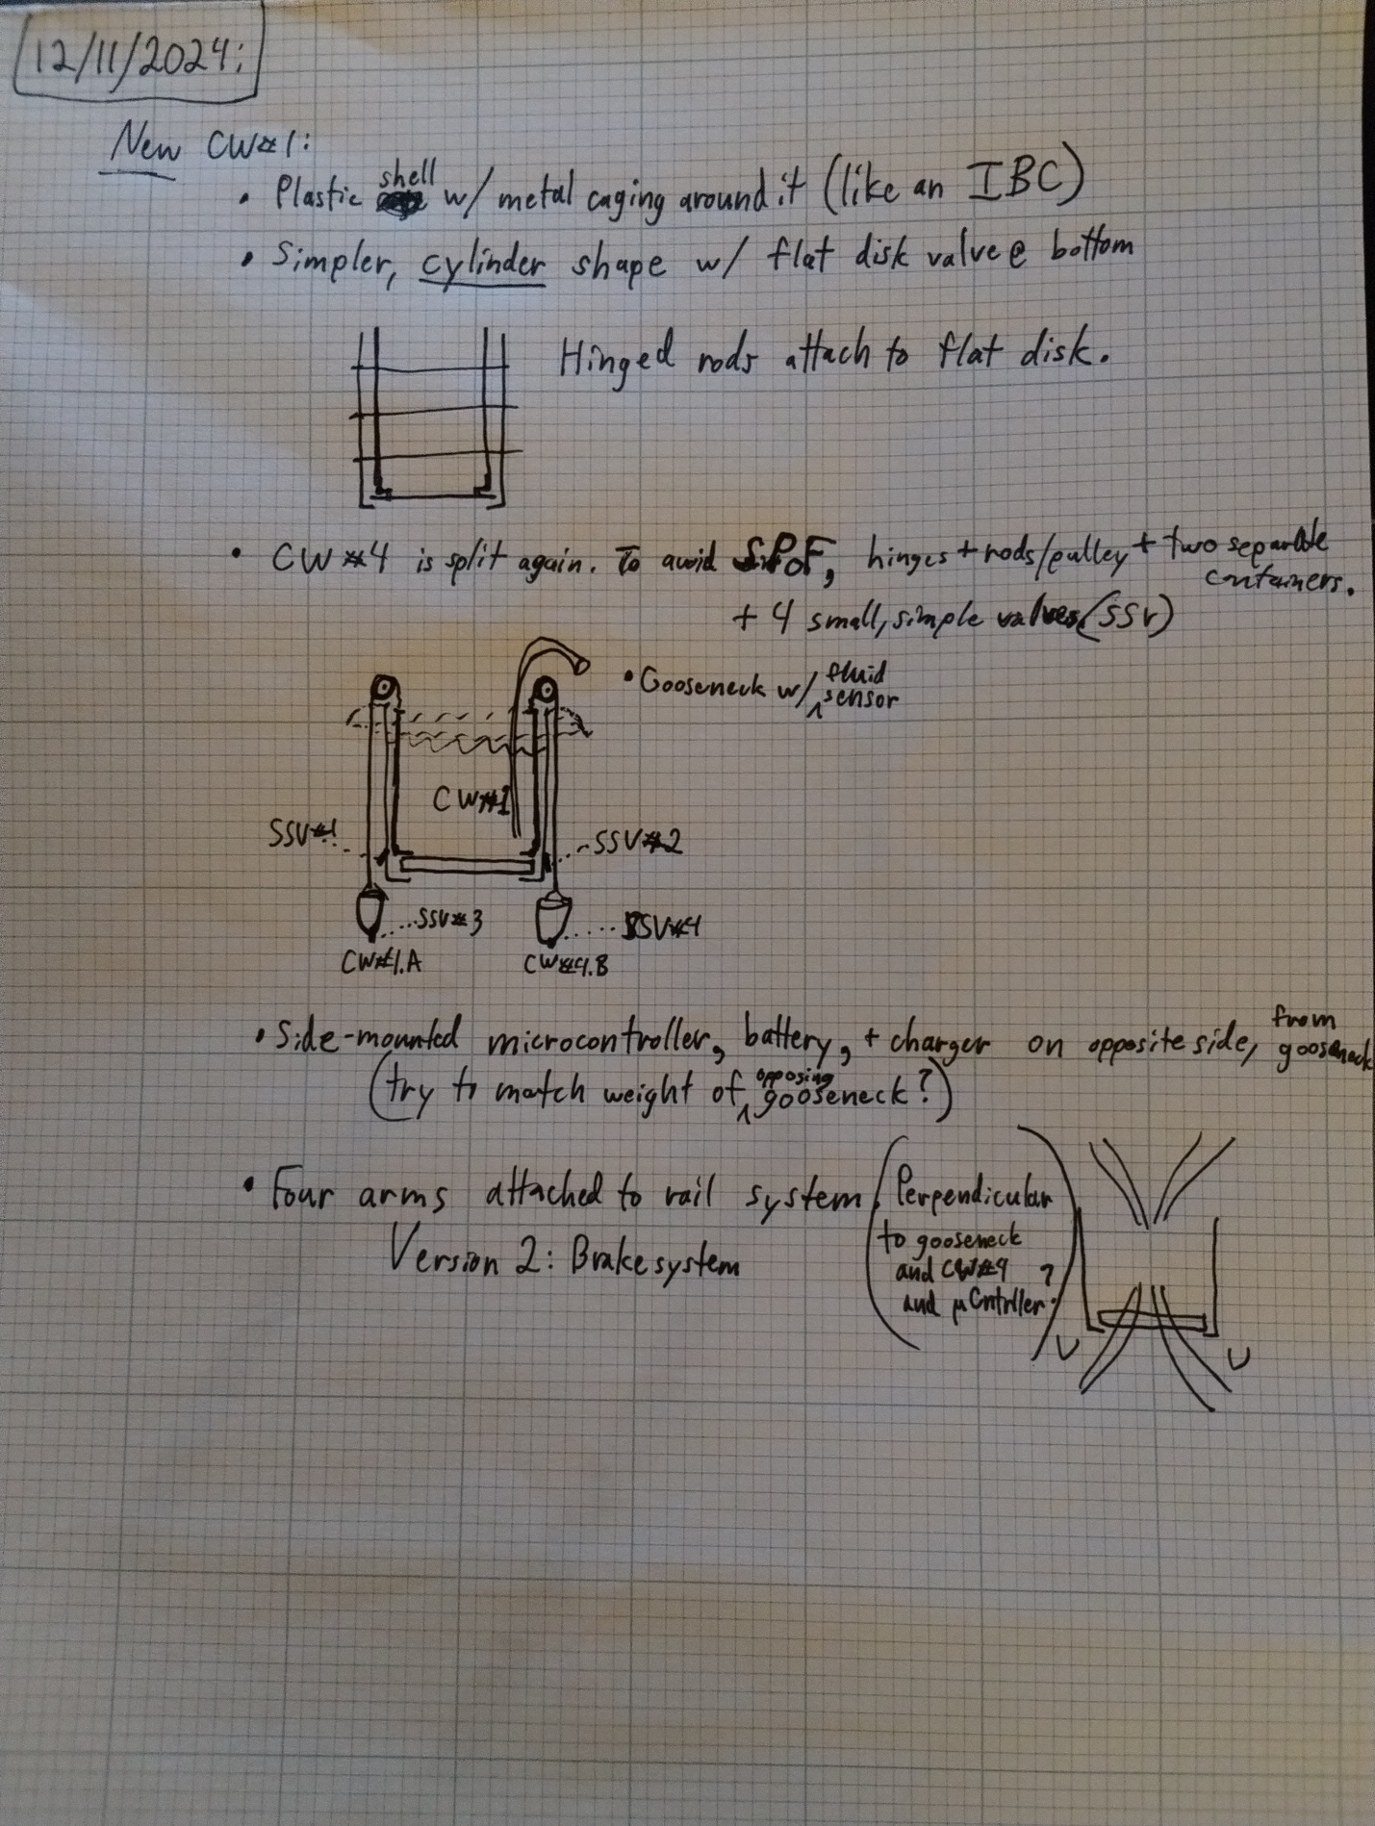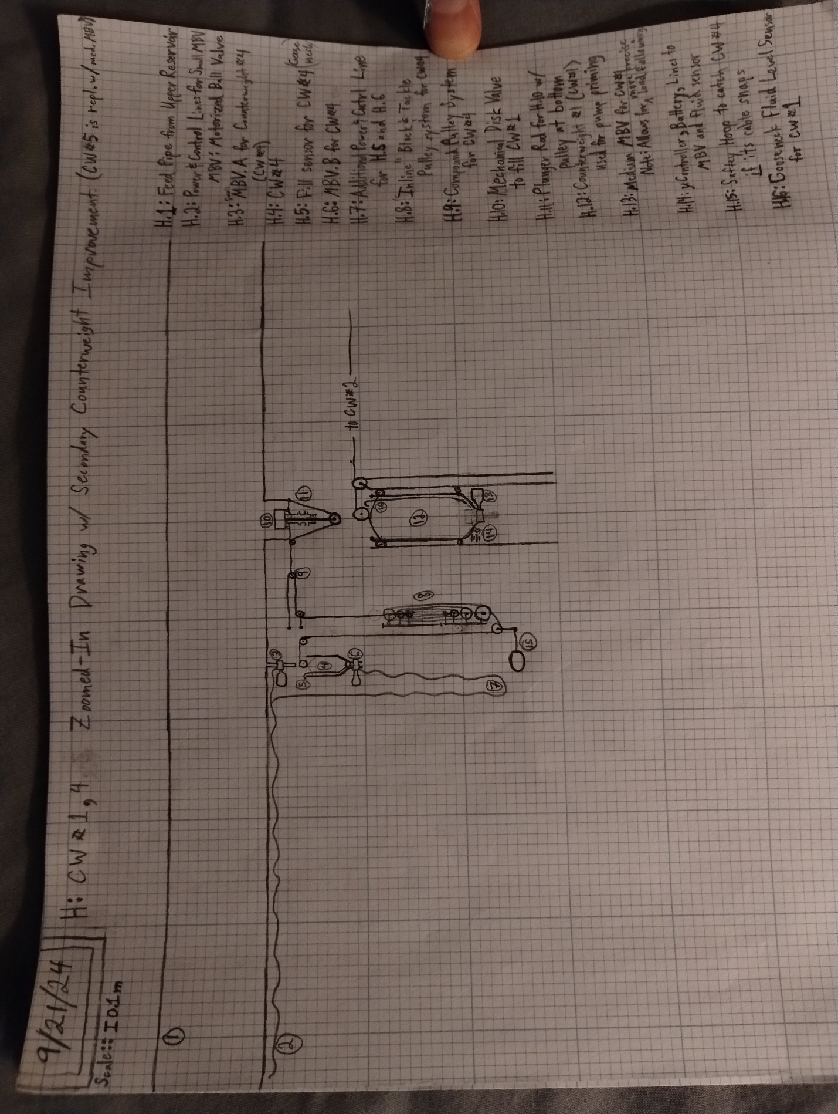

For IP services involving the licensing and billing policies for human individuals and non-AI-oriented companies:

    Contact: [graviticengine@gmail.com](mailto:graviticengine@gmail.com)

   Individual terms should be negotiated over email with a customer. Physical paper documents of any written agreement should be signed by both parties before a deal is considered finalized (i.e. before permission to use any IP owned by Give And Take Info, LLC is ever allowed).

For IP services and billing policy for an AI, an AI-oriented company, an AI-based consortium and any other AI-related-communication partners:

Contact: [graviticengine@gmail.com](mailto:graviticengine@gmail.com)